Email Notification

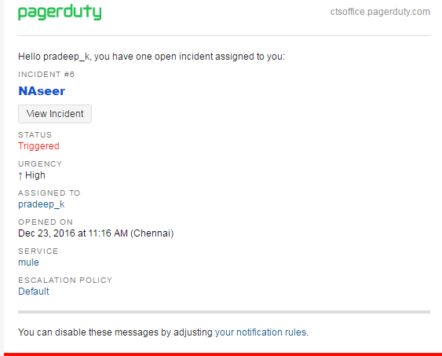

Acknowledge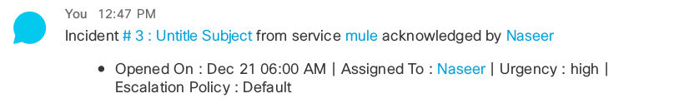

Trigger

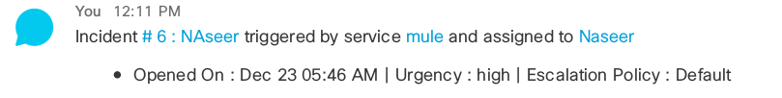

resolve

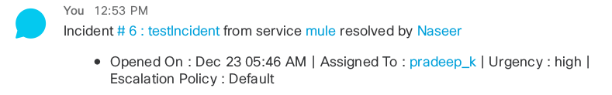

Manually reassign

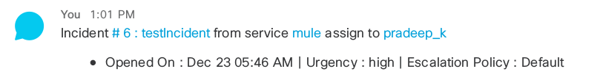

incident escalate

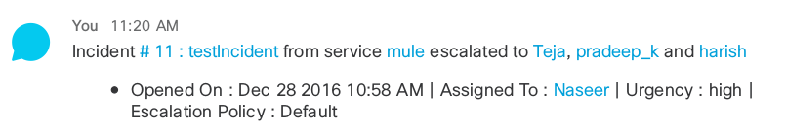

Unacknowledge due to time out

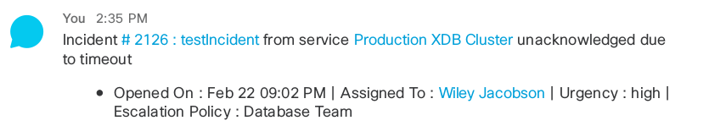

delegate

